**Relations**

A relationis any set of ordered pairs. The set of the first components of each ordered pair is called the **domain (or input)** and the set of the second components of each ordered pair is called the **range (or output)**.

Consider the following set of ordered pairs. The first numbers in each pair are the first five natural numbers. The second number in each pair is twice that of the first.

$$\{ \left(1,2\right), \left(2,4\right), \left(3, 6\right), (4, 8), \left(5, 10\right) \}$$

The domain is $\{1, 2, 3, 4, 5\}$. The range is $\{2, 4, 6, 8, 10\}$.

**Functions**

A function is a relation in which each possible input value leads to exactly one output value. We say “the output is a function of the input”.

Example 1: Determine which of the following relations are functions.

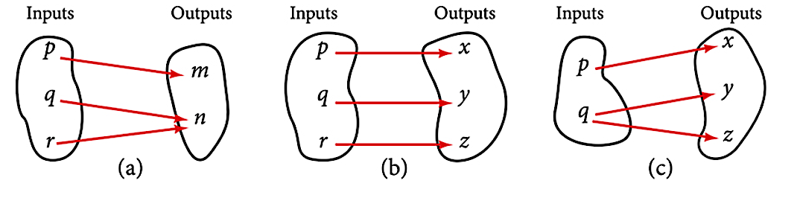

**Function Notation**

The notation $y=f(x)$ defines a function named $f.$ This is read as “ $y$ is a function of $x$”. The letter $x$ represents the input and the letter $y$, or $f(x)$, represents the output.

Once we determine that a relationship is a function, we need to display and define the functional relationships so that we can understand and use them. There are various ways of representing functions, but standard function notation is what we will primarily use in this course.

To represent “height is a function of age,” we start by identifying the descriptive variables $h$ for height and $a$ for age. With these defined, our input is $a$ and our output is $h$. Now if we choose to name our function $f$, we would have

$h=f(a)$ which we read as “ $h$ is a function of $a$”

The parentheses around $a$ indicate that age is input into the function; they do not indicate multiplication. Although the letters $f, g$ and $h$ are often used to represent functions, we can use any letter we want to name the function and its input.

We can also give an algebraic expression as the input to a function. For example, $f(a+b)$ means “first add $a$ and $b$, and the result is the input for the function $f$.” The operations must be performed in this order to obtain the correct result.

Example 2: The number of days in a month is a function of the name of the month, so if we name the function $f$, we write $days=f\left(month\right) \text{or} d=f(m)$. The name of the month is the input to a “rule” that associates a specific number (the output) with each input.

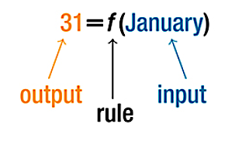

For example, $f\left(January\right)=31$, because January has 31 days. The notation reminds us that the number of days, (the output), is dependent on the name of the month, (the input).

Is the name of the month a function of the number of days?

**Table Form**

A common method of representing functions is in the form of a table. The table rows or columns display the corresponding input and output values. In some cases, these values represent all we know about the relationship; other times, the table provides a few select examples from a more complete relationship.

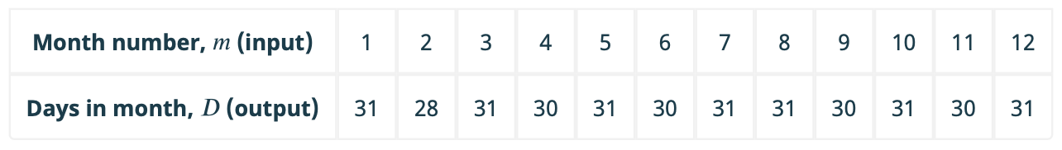

**Finding Input and Output Values of a Function**

When we know an input value and want to determine the corresponding output value for a function, we **evaluate** the function. Evaluating will always produce one result because each input value of a function corresponds to exactly one output value.

When we know an output value and want to determine the input values that would produce that output value, we set the output equal to the function’s formula and **solve** for the input. Solving can produce more than one solution because different input values can produce the same output value.

Example 3: Use the function $f\left(x\right)=x^{2}+3x-4$ to

1. Evaluate $f\left(2\right)$
2. Evaluate $f(a)$
3. Solve $f\left(x\right)=-4$
4. Evaluate $f(a+h)$
5. Use your results from “b” and “d” to evaluate $\frac{f\left(a+h\right)-f\left(a\right)}{h}$

**Finding Input and Output Function Values from a Graph**

Evaluating a function using a graph also requires finding the corresponding output value for a given input value, only in this case, we find the output value by looking at the graph. Solving a function equation using a graph requires finding all instances of the given output value on the graph and observing the corresponding input value(s).

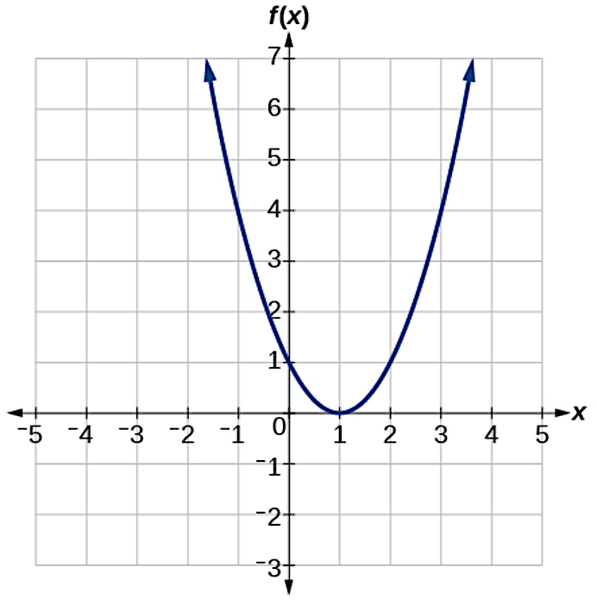

Example 4: Use the graph of $f$ to determine

$f\left(2\right)$

1. $x$ such that $f\left(x\right)=4$

**One-to-One Function**

A one-to-one function is a function in which each output value corresponds to exactly one input value.

Example 5: Is the area of a circle a function of its radius? If so, is it a one-to-one function?

**Vertical and Horizontal Line Tests**

The **vertical line test** can be used to determine whether a graph represents a function. If we can draw any vertical line that intersects a graph more than once, then the graph does not define a function because a function has only one output value for each input value.

Once we have determined that a graph defines a function, an easy way to determine if it is a one-to-one function is to use the **horizontal line test**. Draw horizontal lines through the graph. If any horizontal line intersects the graph more than once, then the graph does not represent a one-to-one function because they only have one input value for each output value.

Example 6: Determine which graphs represent relations, functions, or 1-1 functions.

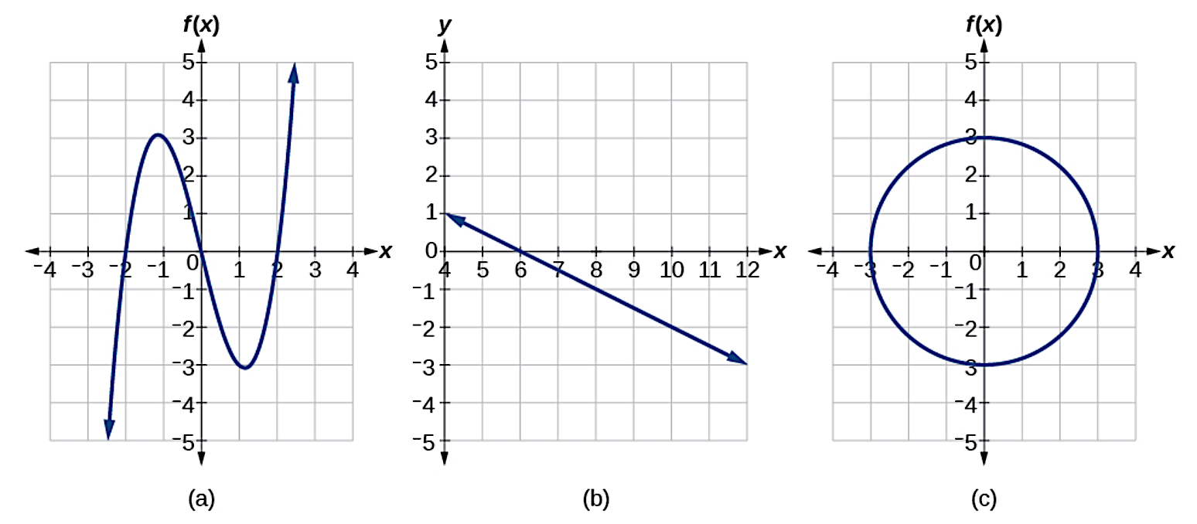

**Domain of a Function**

The domain of a function is a list of the real input values that result in real output values. Since many functions have an infinite number of elements in their domain, it is often easier to start with the assumption that the domain is all real numbers, and then determine any domain exclusions.

Example 7: Determine the domain for each function.

$f\left(x\right)=x^{2}-1$

$f\left(x\right)=\frac{x+1}{x+5}$

$h\left(x\right)=\sqrt{7-x}$

**Domain and Range of a Function from a Graph**

Another way to identify the domain and range of functions is by using graphs. Because the domain refers to the set of possible input values, the domain of a graph consists of all the input values shown on the x-axis. The range is the set of possible output values, which are shown on the y-axis. Keep in mind that if the graph continues beyond the portion of the graph we can see, the domain and range may be greater than the visible values.

Example 8: Determine the domain and range of the function whose graph is below.

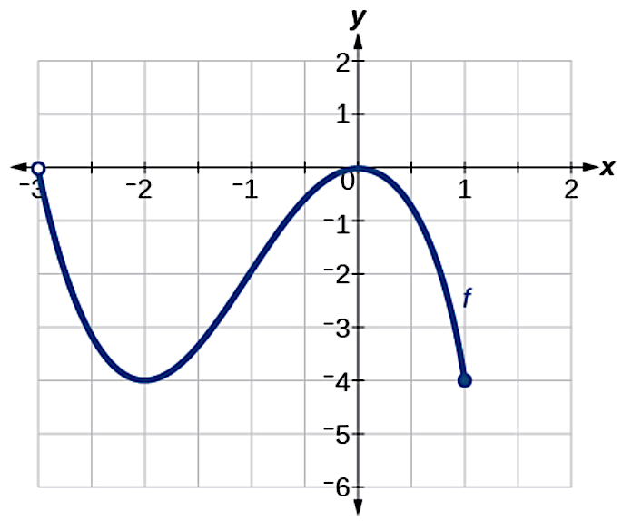

**Piecewise Functions**

A piecewise function is a function in which more than one formula is used to define the output. Each formula has its own domain, and the domain of the function is the union of all these smaller domains.

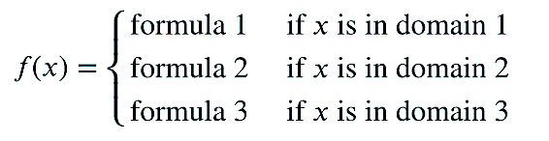

Example 9: Sketch the graph of the function.

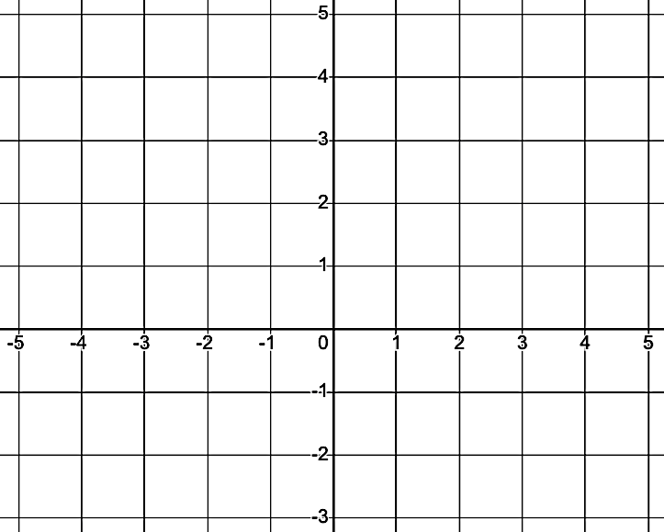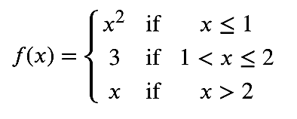

**Increasing, Decreasing, and Constant**

As part of exploring how functions change, we can identify intervals over which the function is changing in specific ways. We say that a function is increasing on an interval if the function values increase as the input values increase within that interval. Similarly, a function is decreasing on an interval if the function values decrease as the input values increase over that interval. If a function is unchanged in an interval, we say the function is constant on that interval.

Example 10: Determine the intervals where the function is increasing, decreasing, and constant.

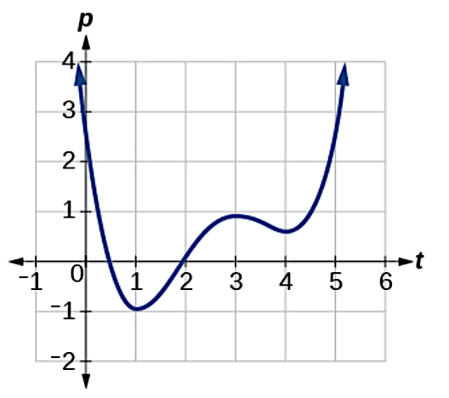

**Extrema (Maximums and Minimums)**

A value of the input where a function changes from increasing to decreasing (as we go from left to right) is the location of a maximum. If this is the highest output, then it is known as an **absolute maximum**, otherwise it is known as a **local maximum.**

Similarly, a value of the input where a function changes from decreasing to increasing as the input variable increases is the location of a minimum. If this is the lowest output value, then it is known as an **absolute minimum**, otherwise it is known as a **local minimum.**

**NOTE**: Absolute (global) extrema can also occur at endpoints but local (relative) extrema cannot.

Example 11: Determine all extrema of the functions graphed below.

